Crime falls 25 percent in Nassau, 22 percent in Suffolk over 5 years, stats show
Police attribute the drops from 2013 to '17 to the effective use of technology and more community outreach. The trend appears to be continuing in 2018, other statistics show.
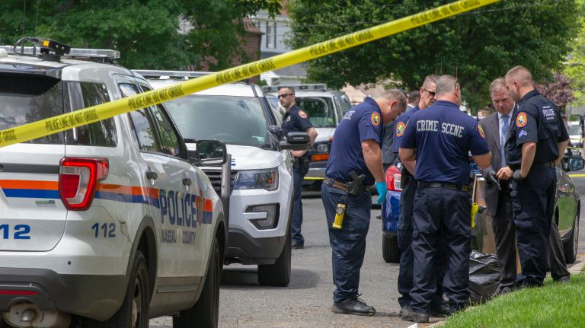
Nassau Police investigate a crime scene on Murray Place in Merrick on June 6. Photo Credit: Howard Schnapp
By Nicole Fullernicole.fuller@newsday.com @NicoleFullerUpdated November 19, 2018 8:34 PM
https://www.newsday.com/long-island/nassau-crime-reduction-1.23587206
Major crime on Long Island plummeted over a five-year period ending in 2017, with a 25 percent drop in Nassau and a 22 percent decrease in Suffolk, and the trend has continued this year, according to police statistics.
Index crimes – defined by the FBI as violent crimes such as murder, rape, robbery and aggravated assault, and property crimes such as burglary, larceny and motor vehicle theft – fell from 18,684 in Nassau in 2013 to 14,016 in 2017. In that same period in Suffolk, there were 26,379 index crimes reported in 2013, compared with 20,543 in 2017.
Police and prosecutors in both counties cited the use of technology, such as surveillance cameras and license- plate readers, crime and opioid-overdose mapping and a concentration on community outreach, as keys to the improvement.
The FBI requires the 18,000 or so police departments across the country to report statistics annually. In New York, police departments report the numbers to the state Division of Criminal Justice Services. The numbers for 2013-17 include all police agencies in each county.
Through November of this year, the decreases in crime have continued, according to police department statistics, which don't include the smaller police departments such as Hempstead village in Nassau and Riverhead in Suffolk. In the area patrolled by Suffolk County police, violent crime and property crime were down 12.8 percent through Nov. 10 this year, compared with the same period last year. In Nassau's policing district, violent crime and property crime decreased 4.2 percent this year through Nov. 18, compared with the same period last year.
Nassau County District Attorney Madeline Singas, speaking at a news conference Monday with Police Commissioner Patrick Ryder and County Executive Laura Curran, branded Nassau the safest large county in the state.
“We’re leaders in Nassau County law enforcement, and these numbers demonstrate it,” Singas said.
Suffolk Police Commissioner Geraldine Hart said in an interview Monday that the county has put a strong effort on not just traditional policing but on outreach to communities, citing the department's recent hiring a Latino civilian liaison.
"All the strategies that we have in place are working," said Hart, who became commissioner in April. “Without question, the number one reason is the men and women who put on the uniform and risk their lives and make Suffolk County the safe place it is."
Suffolk District Attorney Timothy Sini, who was the county's police commissioner from late 2015 until he took over the DA's office in January 2018, cited the use of search warrants and investigations of drug dealers as important ways authorities have attempted to crack down, not only on drug use but also the property crimes that go along with it. Addicts often steal as a way to fund their habits.
“Not only does it take dangerous guns and drugs off the streets, but it disrupts criminal operations from the streets before it’s a major operation,” Sini said.
Joseph Giacalone, an adjunct professor at John Jay College of Criminal Justice in Manhattan and a retired NYPD sergeant, said the crime drop on Long Island largely mirrors national trends, with the exception of some increases in urban areas. But managing the public’s perception of crime can sometimes be more challenging, he said.
“What Nassau and Suffolk are suffering from, I think, is not so much the crime numbers, but the perception of crime,” said Giacalone, citing the spate of killings attributed to MS-13 in the past few years. “Those are vicious crimes that we’ve been hearing about that give the perception that crime is much different than what it used to be on Long Island.”
Singas said the decreases are particularly striking compared with the 1980s and '90s, when crime hit historic highs across the country.
“I started my law enforcement career in 1991 and I know Commissioner Ryder started his even earlier, and we could not imagine these types of reductions in those years," Singas said. "We have the benefit of technological tools, analytics and data sets that were simply unavailable to us in the 1990s.
"Today, when we see a spike in crime in a specific neighborhood, we can micro-target that community and send our resources and enforcement.”

By Nicole Fullernicole.fuller@newsday.com @NicoleFuller
Nicole Fuller is Newsday's senior criminal justice reporter. She began working at Newsday in 2012 and previously covered local government.

